

**Tribhuvan University**

**Faculty of Humanities and Social Sciences**

**E-COMMERCE**

**A PROJECT REPORT**

**Submitted to**

**Department of Computer Application**

**Thames International College**

***In partial fulfillment of the requirements for the Bachelors in Computer Application***

**Submitted by:**

Shikha Khimding

BCA 5th Semester

Reg no: 6-2-450-27-2020

2024/03/24

Under the Supervision of:

**Mr. Kishor Singh**

# **ABSTRACT**

This study delves into the intricacies of establishing a specialized e-commerce platform tailored exclusively for canvas embroidery enthusiasts. Focused on addressing prevailing gaps in the market, the research adopts a comprehensive approach by scrutinizing current market dynamics and discerning the nuanced preferences of consumers engaged in the art of canvas embroidery. By examining trends and behaviors within the canvas embroidery niche, the study seeks to inform the curation of a diverse and high-quality product selection on the proposed platform, accommodating various artistic styles and customization preferences.

Furthermore, the research critically evaluates the efficacy of community engagement strategies within the envisioned platform. It investigates the impact of features such as forums, social media interaction, collaborative projects, and educational initiatives on user satisfaction, retention rates, and the overall cultivation of a supportive canvas embroidery community. The findings of this study not only contribute to the development of a specialized e-commerce platform but also hold broader implications for the sustained growth and enrichment of the canvas embroidery community, emphasizing the importance of a tailored digital space for creative expression.

**Keyword: PHP, web application, database**

# **ACKNOWLEDGEMENT**

We want to extend our heartfelt gratitude to our supervisor, Mr. Kishor Singh, who provided us with a valuable chance to undertake this remarkable project centered around the Online Based Store of Hand-embroidered Products. This opportunity not only allowed us to conduct extensive research but also introduced us to numerous novel tools and technologies.

I am greatly appreciative to Thames International College for their guidance and continuous oversight, as well as for furnishing essential information related to the Project and aiding its successful completion. We are also grateful to our parents and friends who provided valuable assistance in completing this project within the specified time frame.

Lastly, we extend our appreciation to Tribhuvan University for affording us this opportunity through the Computer Application course. This experience has allowed us to gain insights into project ethics at an early stage and has enabled us to enhance our knowledge and skills.

Your Sincerely,

Shikha Khimding

**TABLE OF CONTENTS**

ABSTRACT ii

ACKNOWLEDGEMENT iii

CHAPTER 1: INTRODUCTION 1

1.1 Introduction 1

1.2 Problem Statement 1

1.3 Objectives 2

1.3 Scope and Limitations 2

1.4.1 Scope 2

1.4.2 Limitations 2

1.5 Report Organization 2

CHAPTER 2: LITERATURE RIVIEW 4

CHAPTER 3: SYSTEM ANALYSIS AND DESIGN 5

3.1 System Analysis 5

3.1.1 Requirement Analysis 6

3.1.2 Feasibility Analysis 8

3.1.3 Data Modeling (ER-Diagram) 10

3.1.4 Process Modeling (DFD) 11

3.2 System Design 12

3.2.1 Architectural design 12

3.2.2. System Flowchart 12

3.2.3 Database Schema Design 13

3.2.4 Interface Design (UI Interface) 14

CHAPTER 4: IMPLEMENTATION 16

4.1 Implementation 16

4.1.1 Tools Used (CASE tools, Programming language, Database platforms) 16

4.1.2 Implementation Details of Modules (Description of procedures/functions) 17

CHAPTER 5: CONCLUSION 18

5.1 Lesson Learnt/Outcome 18

5.2 Conclusion 18

REFERENCES 19

# **CHAPTER 1: INTRODUCTION**

## Introduction

The Hand Embroidery E-commerce Platform is meticulously designed to offer a seamless service to individuals seeking to explore and acquire exquisite hand-embroidered products. Serving as a digital hub, this platform streamlines the process of discovering, purchasing, and enjoying handcrafted treasures. With an array of features tailored to enhance the overall experience for both artisans and patrons, our primary aim is to revolutionize the accessibility and appreciation of hand embroidery in the digital age.

At its core, the Hand Embroidery E-commerce Platform facilitates the exploration and acquisition of a diverse range of hand-embroidered products, each a testament to the skill and artistry of talented artisans. Whether its intricate patterns adorning textiles, bespoke apparel embellished with delicate stitches, or finely crafted accessories, our platform offers a curated collection of hand-embroidered wonders to suit every taste and occasion.

In essence, the Hand Embroidery E-commerce Platform is more than just a marketplace; it is a celebration of craftsmanship, creativity, and cultural heritage. By harnessing the power of technology to showcase and promote the timeless art of hand embroidery, we aim to inspire and enrich the lives of both artisans and patrons alike.

## Problem Statement

Manual shopping can be a time-consuming process, especially when customers lack information about price ranges and available items. Oftentimes, individuals seek to purchase something special for their loved ones, particularly teenagers. However, navigating through products and their respective qualities can be challenging. Reviews may not always be reliable, and researching extensively doesn't always ensure the quality of a product. Dishonest sellers who mislead buyers to drive sales contribute significantly to the prevalence of faulty or subpar items.

## 1.3 Objectives

The main objective of this project is to elevate the essence of our customers' cherished moments by offering an exquisite collection of hand-embroidered products. Each meticulously crafted piece embodies a sense of artistry that inspires our customers to express their sentiments through our diverse range of innovative gifts.

Additional objectives of this project encompass:

* Implementing an efficient time management system to ensure prompt order processing and delivery, maximizing customer satisfaction.
* Designing a visually captivating website interface that encapsulates our brand's identity and values, creating an immersive shopping experience for our clientele.

## Scope and Limitations

Each website possesses its distinct attributes and restrictions. This ecommerce presents the following possibilities and is deficient in the following aspects:

### Scope

* This project sheds light on the significance and contemporary trends surrounding handmade goods in Nepal.
* It serves as a platform to explore potential avenues for the growth and promotion of the handicraft business.

### Limitations

* A stable internet connection is necessary to access the platform.
* The system may not allow extensive customization based on specific requirements.

## 1.5 Report Organization

**Introduction**

This section covers the system's introduction, its goals, constraints, and the rationale behind its creation.

**Background Study and Literature Review**

This section will delve into the historical background and evolution of ecommerce, alongside an examination of its contemporary landscape. It will incorporate an overview of pertinent literature and research concerning key factors influencing the growth of ecommerce, as well as various business models and platforms prevalent in the industry.

**System Analysis and Design**

This chapter will outline the systematic process of analyzing and designing the proposed system. It will encompass activities such as gathering requirements, delineating system architecture, and crafting user interface designs. Furthermore, it will offer an in-depth exploration of the system's functionalities and features.

**Implementation and Testing**

In this section, we focus on the tools utilized in developing the system, provide details about the implementation process, and present the outcomes of the tests conducted.

**Conclusion and Future Recommendation**

In this chapter, we briefly discuss the key takeaways, results, and final thoughts of the entire project. We explain what we have achieved and provide a conclusion. Additionally, we outline the potential areas for enhancement and future improvements.

# **CHAPTER 2: LITERATURE RIVIEW**

Recent literature on e-commerce websites underscores the critical interplay between consumer behavior, user experience, and business success. Studies highlight the paramount importance of factors like website design, usability, and mobile responsiveness in shaping user engagement and purchase decisions. Personalization and recommendation systems tailored to individual preferences emerge as effective strategies for enhancing user experiences and increasing conversion rates.

Moreover, establishing trust and ensuring security are identified as crucial elements for fostering customer loyalty and mitigating risks associated with online transactions. Robust security measures, including SSL encryption and fraud detection systems, are imperative to safeguard sensitive customer data. Effective digital marketing strategies, such as social media marketing and SEO, are vital for driving traffic and engaging customers throughout the buyer's journey. Furthermore, efficient logistics and supply chain management are fundamental for fulfilling orders promptly and delivering superior customer experiences. Leveraging emerging technologies like AR, VR, and blockchain holds promise for shaping the future of e-commerce, offering innovative solutions to enhance customer engagement and optimize business operations.

Additionally, recent research explores the impact of sustainability practices on e-commerce, with consumers increasingly prioritizing environmentally-friendly brands and sustainable supply chains. Integrating sustainability into e-commerce strategies not only aligns with consumer preferences but also presents opportunities for cost savings and competitive differentiation in the marketplace. As e-commerce continues to evolve, interdisciplinary research efforts are essential to address emerging challenges and capitalize on new opportunities for growth and innovation in the digital landscape [1].

# **CHAPTER 3:** **SYSTEM ANALYSIS AND DESIGN**

## 3.1 System Analysis

The system follows a well-defined process, starting from analyzing requirements to maintenance. During the requirement analysis stage, both functional and nonfunctional aspects are carefully examined to shape the system accordingly. The design phase constructs a plan based on these requirements, and coding and development follow suit. Testing assesses the system's performance, with issues addressed before implementation. If testing goes well, the system is put into action. Maintenance is performed if needed, ensuring a smoothly functioning system. This systematic approach guarantees a well-crafted and effective solution.

Given the context of designing and implementing a web-based software system, it was essential to acknowledge and consider specific models applied in the development and deployment of software. These encompass generic software development models such as:

* Waterfall methodology: This involves distinct stages of requirements, specification, design, implementation, and testing, treated as separate processes.
* Evolutionary/Incremental Development: This approach involves quickly formulating specifications and subsequently refining them for the client.
* Agile model: An iterative development approach where tasks are broken into smaller iterations, minimizing long-term planning. Project scope and requirements are established at the project's outset.
* System assembly from reusable components: This approach assumes the existence of certain system components. It focuses on integration.

Upon reviewing these models, the Waterfall model suits the development of the Library Management System. This approach allows for individual focus on each model segment during development and enables revisiting as needed. The project's segmentation aligns well with this model.

The development process adheres to these stages:

- Proposal of requirements.

- Formation of system design based on these requirements.

- Implementation of features in line with the design.

- System integration and testing.

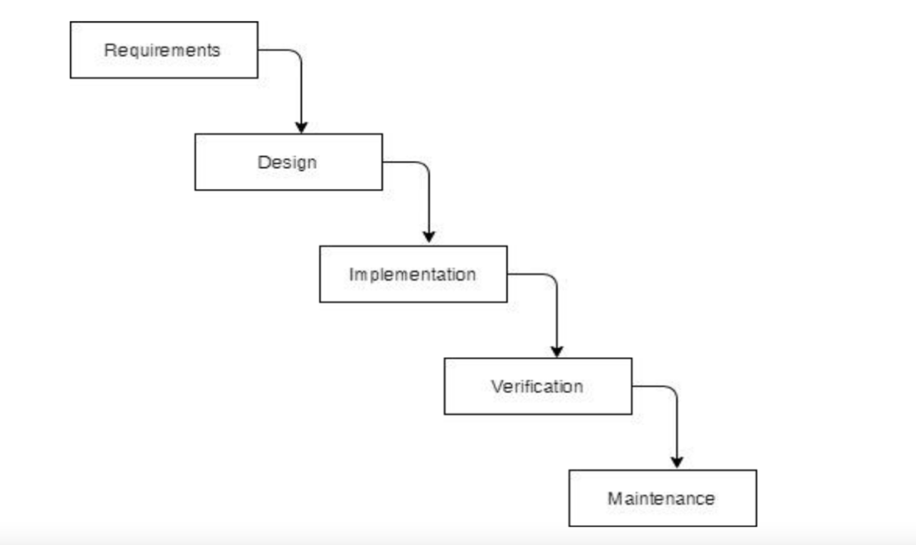

**Figure 3.1** **Waterfall Methodology for E-commerce**

### 3.1.1 Requirement Analysis

The requirements are to be collected before starting projects’ development life cycle. To design and develop system, functional as well as non-functional requirement of the system has been studied.

1. **Functional Requirements**

There are different functional requirements of the system. Some of them are:

* The administrator will have access to the user's information.
* The administrator will also have access to add, update and delete products.
* The administrator will validate the user’s accounts and provide them access to the system.
* Users will be able to create an account and login.
* Users can browse and order the products.
* They can add it to Cart and Wishlist for future purchase.

**USE-CASE DIAGRAM**

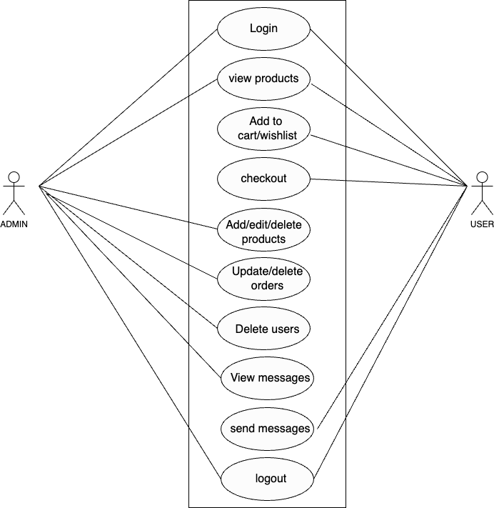

**Figure 3.2** **Use Case Diagram**

1. **Non-Functional Requirements**

There are different non-functional requirements in system. They are:

* System can operate on personal computer and hand-held devices.
* System has its own terms and conditions in order to register user to maintain security.
* System supports multiple users to use the system at once.
* System is fast and easy to use.
* System has very easy user-friendly interface.

### 3.1.2 Feasibility Analysis

The feasibility assessment determined that the project can be successfully executed due to its thorough planning.

1. **Technical Feasibility**

Accessible through various devices like personal computers or smartphones with an internet connection, this system requires no additional hardware for development. Developed using Visual Code on a personal computer, it stands as technically feasible and adaptable to different platforms.

1. **Operational Feasibility**

The suggested system operates entirely through a graphical user interface (GUI), ensuring simplicity in its usage. Its user-friendly design facilitates effortless operation, affirming its complete and efficient functionality.

1. **Economic Feasibility**

Utilizing freely available software during development, this system imposes no additional costs. With only a personal device and internet connection required for usage, it remains economically viable and accessible to users without financial constraints.

1. **Schedule Feasibility**

The system which we are going to develop will be completed within scheduled time and will not exceed the scheduled time.

Table 3.1 Gantt Chart Table for E-commerce

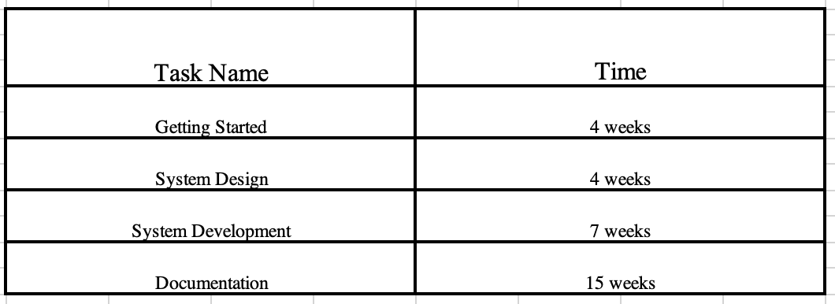

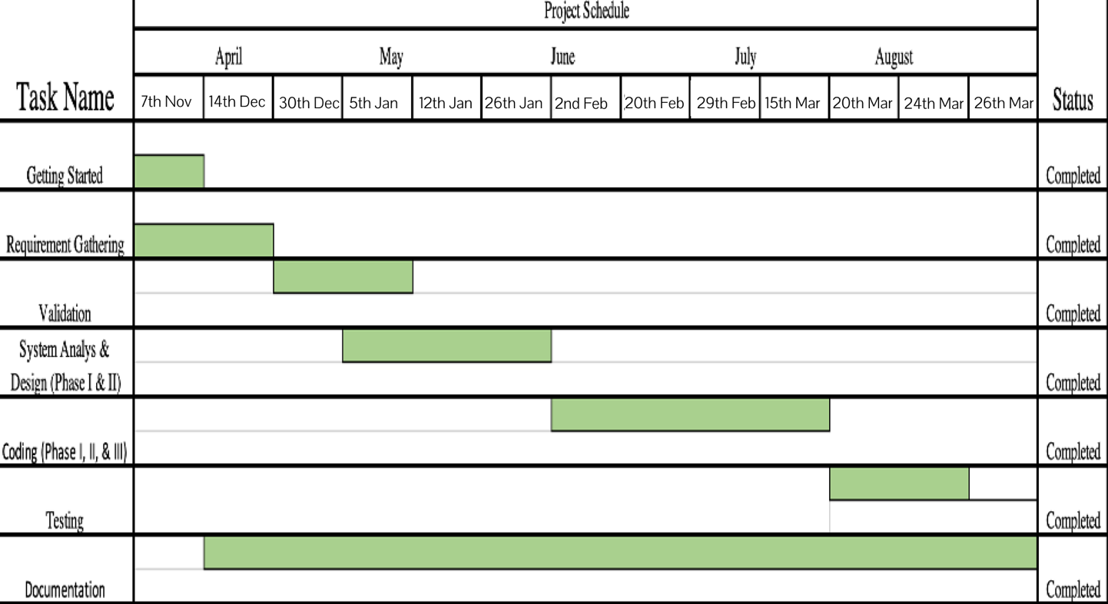

Figure 3.3 Gantt Chart for E-commerce

### 3.1.3 Data Modeling (ER-Diagram)

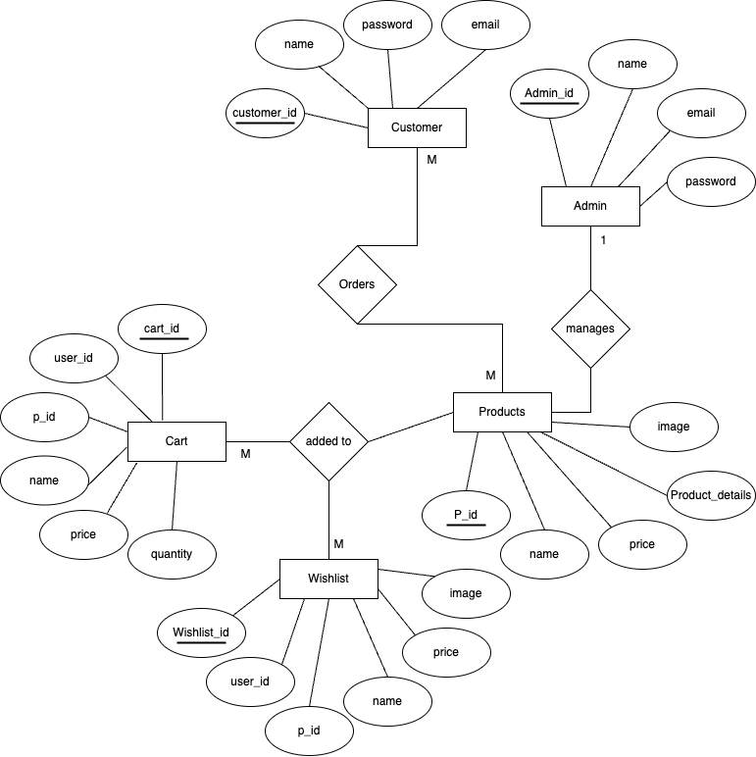

Figure 3.4 ER Diagram of E-commerce

### 3.1.4 Process Modeling (DFD)

A Data Flow Diagram is a graphical representation that shows how data flows through a system, including processes, data stores, data sources, and destinations. In the context of an E-commerce the DFD will illustrate the different components of the system and how they interact with each other in terms of data flow.

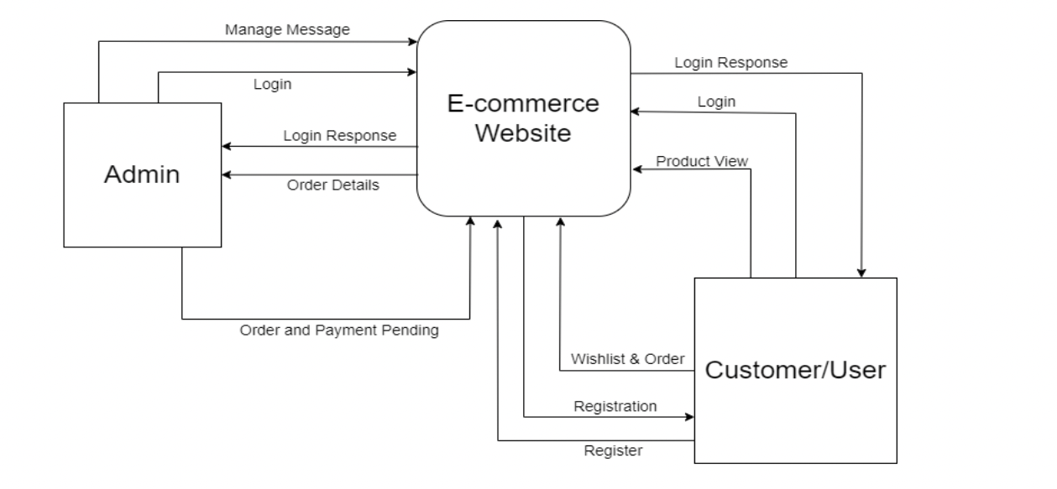

Figure 3.5 Level 0.0 DFD of E-commerce

## 3.2 System Design

Diagrams representing various design aspects of the system have been created to visually depict its diverse functional requirements. These design diagrams include the following:

### 3.2.1 Architectural design

The system employs a three-tier architecture consisting of a user interface, web server, and database. This architectural design illustrates the fundamental framework of the system.

### 3.2.2. System Flowchart

The diagram depicted below outlines the flowchart of E-commerce system. In this scenario, both admin and users access the system through login credentials. If a user is not yet registered, they are required to complete the registration process. Once the login is successful, they are directed to their respective dashboards. For admin and users, the process is slightly different: administrators can directly access the system without registering, whereas users need to complete the registration step. Finally, both administrators and users have the option to log out of the system after completing their tasks.

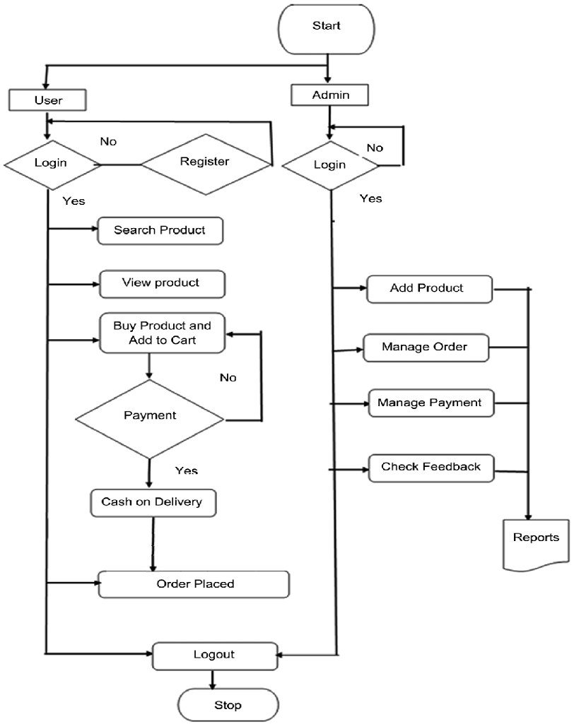

Figure 3.6 Flowchart of e-commerce

### 3.2.3 Database Schema Design

The illustration provided below represents the database schema design of the library management system. The database schema design serves the purpose of showcasing the fundamental framework of the system. Within the library management system, six distinct tables exist within the database, each of these tables encompassing their own set of attributes. The primary key within each table is represented by its unique ID, and if this ID is referenced in another table, it assumes the role of a foreign key. Foreign keys establish connections between tables, symbolized by lines linking the respective entities. The data type associated with each entity is also specified in the schema. The presence of a foreign key is denoted by an arrow in the diagram.

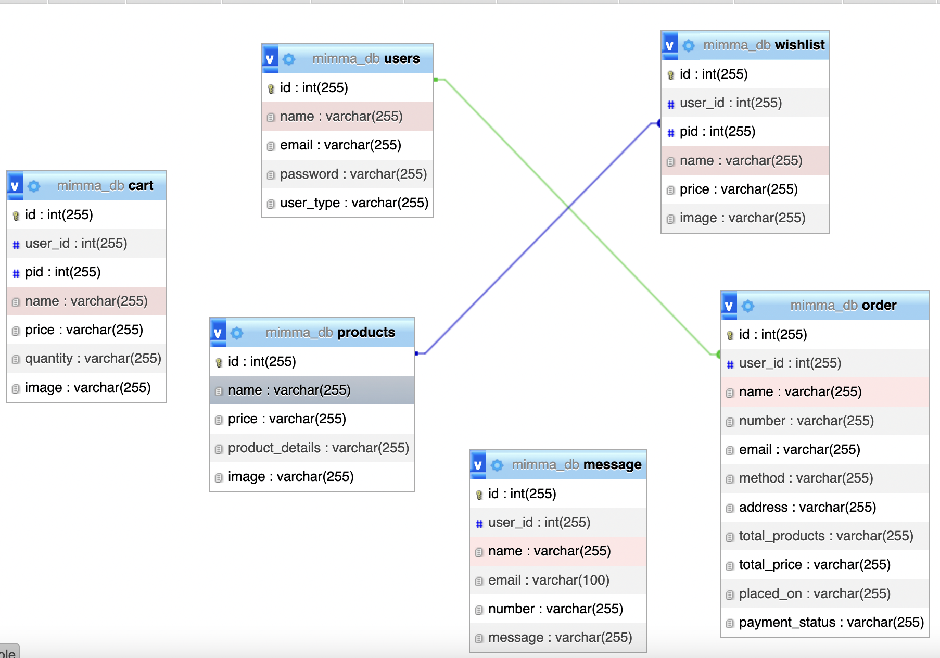

Figure 3.7 Database Schema Design of E-commerce

### 3.2.4 Interface Design (UI Interface)

Interface design is employed to create the visual appearance of the library management system, providing users with a preview of the system's visual layout. Once this design is confirmed, the process of system development commences. The user interface (UI) design for various pages, including the home page, registration page, login page, and dashboard page of the library management system, is illustrated below:

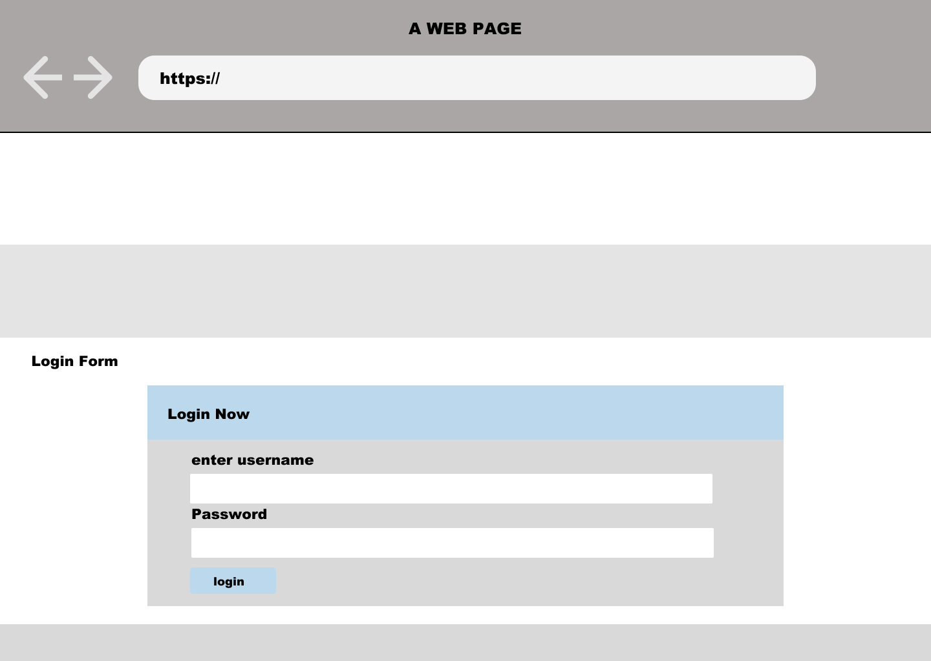

Figure 3.8 login form of E-commerce

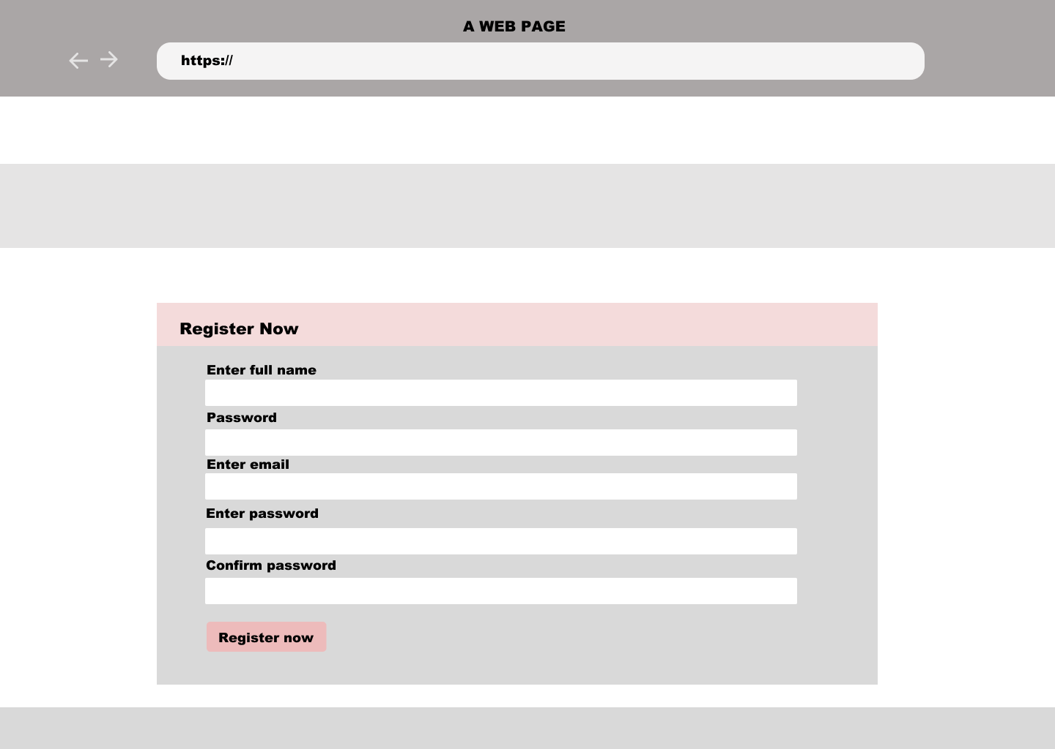

Figure 3.9 Registration form of E-commerce

# **CHAPTER 4**: **IMPLEMENTATION**

## 4.1 Implementation

### 4.1.1 Tools Used (CASE tools, Programming language, Database platforms)

The implementation of an E-commerce involved a range of tools and frameworks to ensure the successful realization of the project's objectives. These tools were employed for both front-end and back-end development, contributing to a comprehensive and functional system.

**Front End Tools**

* **HTML:** HTML was instrumental in creating and structuring various webpages and sites within the Library Management System. It enabled the formation of sections, headings, links, and paragraphs through a variety of tags and elements. The system's headers, paragraphs, links, and images were defined using HTML.
* **CSS:** Cascading Style Sheets (CSS) played a crucial role in designing different HTML elements. Employed through inline, internal, and external CSS, it enabled the creation of appealing styles for webpage components. CSS was utilized to control text color, font styles, paragraph spacing, column sizing, layout designs, and more.
* **JavaScript:** JavaScript was employed to enhance the system's interactivity, responsiveness, and dynamic behavior. This scripting language facilitated client-side validation and added special effects to the webpages.

**Back End Tools**

* **PHP**

PHP served as the backbone of the back-end in the E-commerce, providing dynamic web page capabilities. It enabled server-side scripting, database connectivity, data encryption, user data validation, and more. Functions such as data addition, updating, and deletion were executed using PHP.

**Server**

* **APACHE SERVER:** The Apache server played a pivotal role in the system by running PHP files, ensuring the seamless execution of dynamic web pages.

**Database**

* **MySQL:** The MySQL database platform was instrumental in storing and managing all necessary information. It supported Create, Read, Update, and Delete (CRUD) operations, enabling efficient data management and retrieval.

**Documentation Tools**

* **MS Office**

MS Office tools were employed to write and edit documentation related to the E-commerce.

* **Draw.io**

Draw.io was utilized for generating diagrams that depicted system analysis and design. This tool expedited the diagram creation process through its drag-and-drop functionality.

### 4.1.2 Implementation Details of Modules (Description of procedures/functions)

The E-commerce consisted of various modules, each serving specific functions within the system:

* Home page module: Users are welcomed with a front content page.
* Registration module: This module is responsible for the signing up process for the users. This module allows users to register.
* Log In module: This module handles the logging in process of users.
* Log Out module: This module ends the session of a logged in user

# **CHAPTER 5:** **CONCLUSION**

## 5.1 Lesson Learnt/Outcome

Each project contributes to our learning and knowledge acquisition across various domains. In this particular project, I have developed problem-solving skills, honed ability to independently discover solutions, understood the importance of following guidelines, enhanced communication and writing abilities, and practiced effective team management.

This project has provided me with valuable insights into problem-solving techniques, enabling to identify and effectively address various issues that arise within the system. Through this project, I’ve acquired the skills necessary to create project proposals and documentation. Additionally, I've become adept at utilizing diverse case tools for tasks like constructing use case diagrams, schema diagrams, data flow diagrams, ER diagrams, and similar elements.

## 5.2 Conclusion

We have effectively launched the "Mimma” an E-commerce website, a platform designed for handmade shopping. This web-based application simplifies the process of searching, viewing, and selecting products. It offers users an efficient way to interactively search for products, with the search engine tailored to their needs. Users can contribute their own reviews, both positive and negative, enhancing the website's interactivity. Our focus during development was on creating a user-friendly environment, ensuring ease of interaction for visitors. This compatibility fosters frequent visits to the website. Through the integration of various links and tools, we have created a functional site that will soon be live and operational. Our efforts have addressed the needs of both users and administrators. Ultimately, we anticipate that these enhancements will contribute significantly to the website's popularity.

# **REFERENCES**

|  |  |
| --- | --- |
| [1] | Zwass, V. (2003). "Electronic Commerce and Organizational Innovative: Aspects and Opportunities," International Journal of Electronic Commerce, vol. 7, no. 3, pp. 7-37. |
| [2] | Heijden, H., & Verhagen, T. (2004). "Online store image: conceptual foundation and empirical measurement," Information & Management, vol. 41, pp. 609-617. |
| [3] | Bucy, E.P., et al. (1999). "Formal features of cyberspace: relationships between web page complexity and site traffic," Journal of the American Society for Information Science, vol. 50, no. 13, pp. 1246-1256. |